FRC Operator Interface Control Board

Developed by: Ryan Nazaretian [ryannazaretian@gmail.com](mailto:ryannazaretian@gmail.com), FRC 364 & 4901

The FRC Operator Interface Control Board (OICD) provides teams with an easy to use interface to connect remote sensors and actuators to their robot such as servos for gauges, LEDs, switches, buttons, and potentiometers.

Built on top of an ATmega 2560 and flashed with the Arduino bootloader, it provides teams for even more customizability with an easy-to-use platform that many of them are already familiar with.

The electrical connections are where this board is really unique compared to other options for FRC teams such as the Cypres PSoC board or TI LaunchPad. This board utilizes the two and three pin connections that are used for PWM cables and for the Robot Signal Light to individually connect peripherals to the OICD. This means that adding, removing, or replacing a switch is as easy as unplugging and/or plugging a new one back in.

The OICD features:

* 16 analog inputs (3-pin, Ground, +5V, Signal)
* 16 digital inputs (2-pin, Ground, Signal)
* 11 PWM outputs (3-pin, Ground, +5V, Signal)
* 16 20mA LED outputs (2-pin, Signal, +5V)
* USB powered

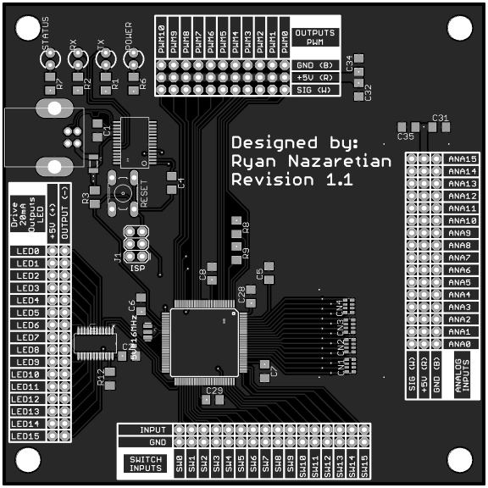

Figure . Top view

Team Fusion 364 has been using the first revision of this board for 2 years now.

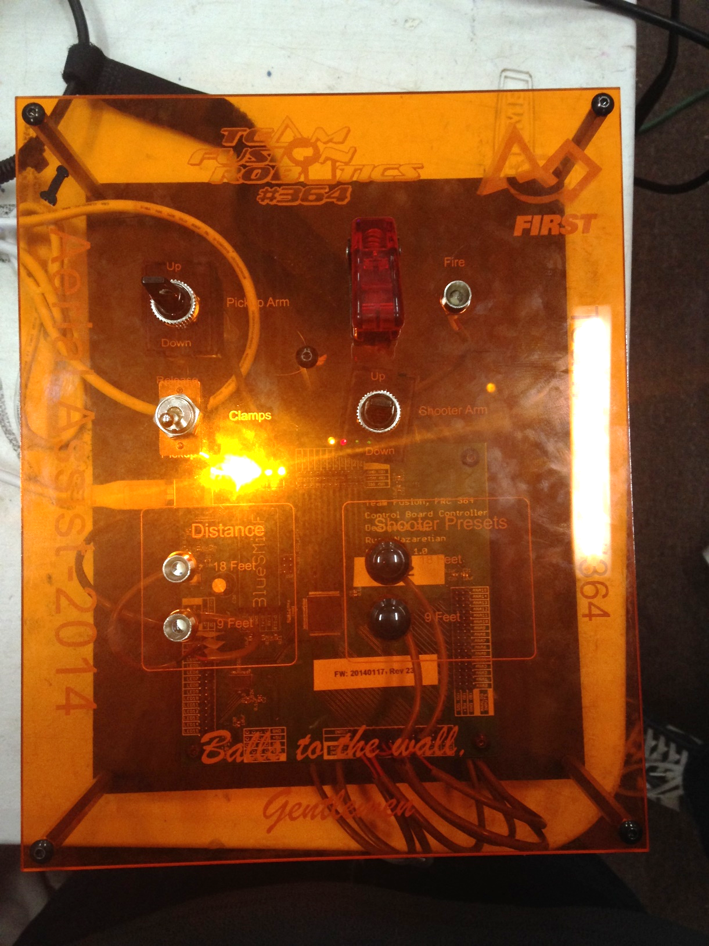

Figure . 2014 Team Fusion Control Board

All the design files are located at [Garnet Squadron’s GitHub](https://github.com/GarnetSquardon4901/FRC-4901-Garnet-Squadron/tree/master/Projects/FRC%20Operator%20Interface%20Control%20Board).

Electrical design was done in Eagle, firmware is Arduino compatible, and FRC library available for the FRC Dashboard. I may have to overhaul it a bit to make it even easier to use with the NT variables when PCB v1.1 finally delivers to me.